CREDIT CARD FRAUD DETECTION USING MACHINE LEARNING

TABLE OF CONTENTS
Chapter 1: Introduction 5
1.1 Problem Description, Context and Motivation 5
1.2 Project Aim 6
1.3 Research Questions 6
1.4 Research Objectives 6
1.5 Methodology 6
1.6 Legal, Social, Ethical and Professional Considerations 7
1.7 Background 8
1.8 Structure of Report 8
1.9 Research Timeframe 9
Tasks / Sections 10
1. Introduction 10
Research Background 10
Aim & Objectives 10
Research Questions 10
Rationale 10
2. Literature Review 10
Empirical Study 10
Theories & Models 10
Literature Gap 10
3. Methodology 10
Research Method & Design 10
Analytical Tools 10
Research Data 10
Research Process 10
4. Data Analysis 10
Data Preprocessing 11
Handling Imbalance 11
Model Training 11
Model Evaluation 11
Visualisation 11
5. Discussion 11
Interpretation 11
Comparison with Literature 11
6. Conclusion 11
Linking with Objectives 11
Recommendations 11
Summary 11
Final Editing & Proofreading 11
Chapter 2: Literature and Technology Review 13
2.1 Introduction to the Literature Review 13
2.2 Technology Review 13
2.2.1 Traditional Fraud Detection Approaches 13
2.2.2 Machine Learning in Fraud Detection 14
2.2.3 Deep Learning and Advanced Techniques 15
2.2.4 Class Imbalance Problem 15
2.2.5 Evaluation Metrics in Fraud Detection 16
2.2.6 Ensemble and Hybrid Models 16
2.3 Research Gaps and Limitations 17
2.4 Summary 17
Chapter 3: Implementation 18
References 26

Chapter 1: Introduction

1.1 Problem Description, Context and Motivation
The enormous growth of online payment systems and the internet-based stores has had major impacts on driving up the number of online credit card payments across the world. Although such transformation has made financial systems more convenient and accessible, it has equally brought about significant vulnerabilities in financial systems. Credit card fraud, which can be described as the use of the details related to cards without the owner participating in any type of financial activities, is a consistent and developing menace. Fraudulent transactions cost the financial institutions large amounts of money on an annual basis causing them to end up incurring immense monetary losses [1].
It is noted that the conventional fraud detection mechanisms are based on rule-based components and pre-established thresholds and patterns. Despite being effective in recognizing familiar fraud behaviours, such systems show reasonable levels of adaptability in face of new and advanced fraud schemes. Fraudsters are also taking advantage of this weakness and imitate valid patterns of transactions to undermine the efficiency of more static methods of detection [2].
It is especially tricky because the datasets on the transactions are highly unbalanced with the fraud cases constituting an incredibly small segment of the overall transactions. Such an unbalanced distribution causes biased performance of the models when not adequately dealt with because in normal classification, the majority class is favoured. Moreover, the need to perform real-time detection also adds more difficulties to it, as systems should provide correct predictions with low latency [3].
This is an issue that has several stakeholders. The financial losses and operational expenses of the financial institutions, chargebacks and reputational damage on the merchants and inconvenience, financial stress, and lower trust of digital payment systems on the customers are direct financial costs. Also, regulators consider secure and transparent financial ecosystems as important issues to be addressed [4].
Under these conditions, it is possible to find the application of machine learning methods as a possible solution. Transactional data with high volumes can be analyzed and the concealed trends identified by machine learning models, and new fraud habits adjusted to. The guiding power behind the present project is the assessment of the efficiency of these models in resolving the issue of data imbalance, advancing the precision of detecting fraud, and sustainable efficiency of fraud detection systems in real financial settings.

1.2 Project Aim
The overall goal of the project is to create and test three machine learning based algorithm such as Logistic Regression, Random Forest and XGBoost that will identify credit card fraud through an open source dataset. The project aims at determining the enhancement of the accuracy of detecting fraud and managing the issue of large scale imbalanced data of the transactions.

1.3 Research Questions
- What is the efficiency of machine learning models to detect fraudulent credit card transactions with highly imbalanced data?
- What transaction characteristics impact the most on performance in the detection of fraud?
- Which machine learning algorithms exhibit the better precision and recall, as well as general detection capability?
- Which evaluation metrics are most appropriate to the processes of determining the fraud detection models beyond the fundamental accuracy?

1.4 Research Objectives
- To process and analyse an open source credit card transaction dataset with Python to prepare it to be analysed by machine learning.
- To develop and evaluate three machine learning models in detecting credit card fraud.
- To compare the performance of models using the relevant measures that include precision, recall, F1 score and area under the curve.
- To determine the machine learning method that will produce the best fraudulent transaction detection with minimum false positives.

1.5 Methodology
Design
In this study, quantitative experimental design is adopted. The dataset available in Kaggle includes anonymised features of transactions and is applicable in the learning task that is based on supervision. The normalization and feature scaling of data and the use of class balancing techniques including over and under-sampling methods are used to increase the model performance.
Three machine learning algorithms are chosen, which will be relevant in extant literature. The logistic regression uses a more interpretable model, the random forest has an advantage of being robust due to its use of ensemble learning and the XGBoost is better in predictive practice based on the principle of gradient boosting [13][14].
Testing and Evaluation
The cross-validation is used to conduct model evaluation in order to guarantee generalisation and prevent overfitting. Since the data is imbalanced, the evaluation is done with the help of precision, recall, F1 score, and ROC-AUC. These measures give a clear picture of the level of fraud detection especially in detecting cases of minority classes [2].
Project Management
The project is developed according to a systematic methodology, and the phases will include preprocessing of the data, implementation of the model, evaluation, and analysis. Jobs are in series, which provides methodical advancement and reproducibility of findings.
Technologies and Processes
The implementation is done with Python because it has a comprehensive support of data analysis and machine learning. Pandas and NumPy libraries are employed to manipulate data and scikit-learn and XGBoost are used to develop models. Results visualisation is done using matplotlib. The extensively used tools are both academic and industrial meaning that they are well-reliable and reproducible.

1.6 Legal, Social, Ethical and Professional Considerations
The dataset in this project is not only anonymised but publicly available and this factor minimises legal issues touching on data privacy. Nonetheless, data handling practice must adhere to data protection policies as well as data science practices as mandated by ethical research practices [5].
The possible effects of the false positive should be taken into account ethically since the small purchases made in the belief of being a fraud can inconvenience the users. Moreover, training data bias can lead to unjust results of some users, which means the sensitivity of fairness and transparency in model development [7].
With regards to social dimensions, efficient fraud detection tools increase the confidence in online payment systems and lead to financial safety. Nevertheless, the overdependence on automated systems can decrease the level of transparency in making the decisions, which are to be considered carefully [9].
Rigorous evaluation approaches and reporting should be observed professionally in a bid to earn credibility. There should be no problems of data leaking as well as the provision of false performance indicators to ensure the research integrity [12].

1.7 Background
The amount of credit card fraud has become a major research topic as a result of the growing use of digital financial systems. Machine learning techniques have been substituting the traditional methods of detection, which can detect sophisticated and dynamic fraud patterns.
Recent research suggests that state-of-the-art machine learning approaches and ensemble techniques outperform the conventional models in fraudulent transaction detection [13]. Moreover, according to the research, it is necessary to discuss the issue of class imbalance and choose the right evaluation measures to guarantee the rightful performance [16].
The open-source datasets have enabled experimentation and comparative analysis thus researchers have been able to evaluate various algorithms under similar conditions. Irrespective of these developments, issues of real-time detection, scalability and changing fraud techniques are among the key research areas of concern [17].
This project takes the current studies further in practice, use, and comparison of machine learning techniques currently in use in a formal and practical environment.

1.8 Structure of Report
The report has been structured in five chats.
Chapter 1 presents the theoretical problem of the research, objectives, methodology, and background.
The second chapter discusses an appropriate literature and technology review with current studies, methods of machine learning, and trends in the detection of fraud.
Chapter 3 outlines the process of implementation which includes preprocessing of data, model development and system design.
Chapter 4 will offer the evaluation and findings, as well as analysis of the model performance and contrast with the related literature.
Chapter 5 wraps up the study with the summary of the findings, limitations, and future research directions, and a reflective discussion.

1.9 Research Timeframe

Tasks / Sections | W1 | W2 | W3 | W4 | W5 | W6 | W7 | W8 | W9 | W10

1. Introduction

Research Background

Aim & Objectives

Research Questions

Rationale

2. Literature Review

Empirical Study

Theories & Models

Literature Gap

3. Methodology

Research Method & Design

Analytical Tools

Research Data

Research Process

4. Data Analysis

Data Preprocessing

Handling Imbalance

Model Training

Model Evaluation

Visualisation

5. Discussion

Interpretation

Comparison with Literature

6. Conclusion

Linking with Objectives

Recommendations

Summary

Final Editing & Proofreading
Table 1: Research Timeframe
(Source: Self-made)
This study will start on 30 March 2026 and will end at 7 June 2026 in ten weeks. The Introduction will commence in Week 1, during which the research background, aim, objectives, questions, and rationale will be drawn to have a direction on the study. The Literature Review will be performed between Weeks 2-4, with critical evaluation of empirical research, machine learning implementations, and research gaps in the field of fraud detection.
The Methodology will start in Week 4 and go through to Week 6. This step will follow a quantitative experimental methodology, outlining data sources, pre-processing methods, and analysis packages python, Scikit-learn, and XGBoost. Weeks 5-8 The Data Analysis will include models implementation, class imbalance, and performance evaluation in terms of precision, recall, F1-score, and ROC-AUC.
The Discussion will be conducted during both Weeks 8 and 9, which will interpret the results and compare findings with the literature. Lastly, Conclusion will be done during Weeks 9-10 with findings being tied to objectives and recommendations, and then there will be final review and revision.

Chapter 2: Literature and Technology Review

2.1 Introduction to the Literature Review
The introduction of digital payment systems has induced the growth of credit card fraud and its complexity, which has become an important field of research in the field of financial technology. The available literature emphasizes a shift towards machine learning solutions to replace traditional rule based-based system, which would be more flexible and predictive. Even though great progress has been made, issues like class imbalance, development in scamming schemes, and generalisation of models are still there. According to recent works, although machine learning is beneficial in improving the performance of detection, practical use is limited by the challenge of interpretability and scalability [10]. This literature review explores the methods used either critically, according to strengths of the methodology, limitations, and future research: prospects in fraud detection.

2.2 Technology Review
In this section, the technological strategies that can be used in the project are assessed and the choice of methods justifies their selection. Despite such a wide range of algorithms, the focus of the research article lies on the supervised machine learning algorithms since the latter are established to be effective, and labelled data sets are readily available. They are implemented using tools such as Python and machine learning libraries since it provides the flexibility and scalability required in a fraud detection system, as well as integration with other technologies.

2.2.1 Traditional Fraud Detection Approaches
The initial systems of fraud detection were mostly rule-based and statistical, which are founded on minimal and expert experience. Such systems work by marking transactions that are not within the set limits like an unusually high number of transactions or uncharacteristic geographic areas. As much as these approaches are interpretable and easy to implement, they have severe limitations.
There has been realization that rule-based systems are actually static and have to be constantly updated manually in order to be effective. According to Patel (2023), such systems are unable to keep up with changing trends in fraud, and their accuracy to detect it decreases as time progresses [6]. Equally, Boutaher et al. (2020) state that the traditional practices are reactive instead of predictive, as they rely on fraud behaviour detection made in the past [17]. Most importantly, such processes have high false positive generation which results in customer dissatisfaction and inefficiency of operation. Moreover, they lack the capability of embracing non-linear identification of complex associations on transaction data, and thus cannot be effective in the current financial situations. Traditional systems will therefore offer a core base but cannot penetrate the dynamic character of the modern-day fraud.
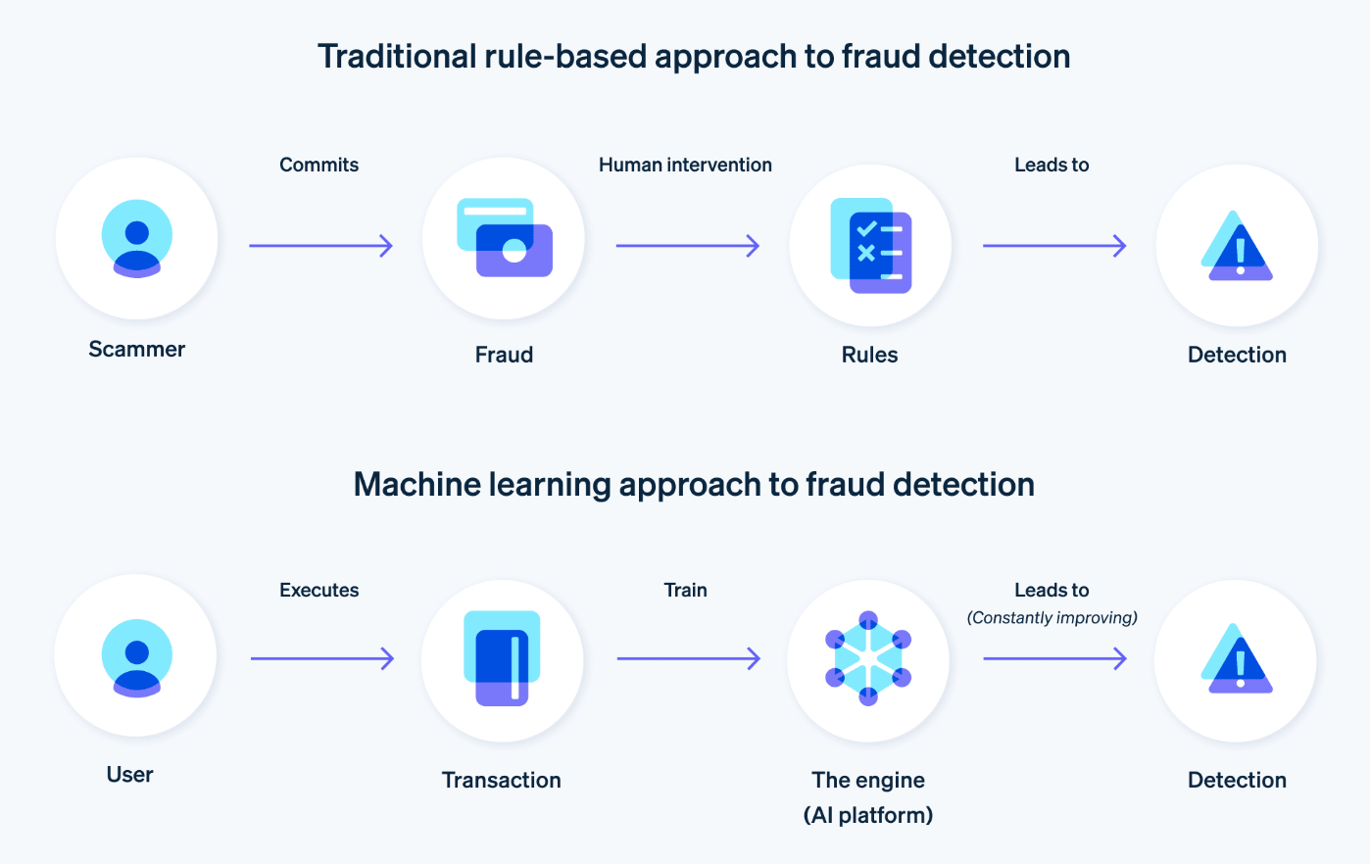
Figure 1: Traditional V/s Machine learning technique
(Source: Reshma et al., 2023)

2.2.2 Machine Learning in Fraud Detection
Machine learning has emerged as a powerful solution with respect to fraud detection since it has the ability to acquire patterns based on previous transaction data and respond to changing fraud patterns. These methods of supervised learning include Logistic regression, Decision trees, random forest and support vector machines, and they are commonly used in this industry. Tiwari et al. (2021) demonstrate that machine learning algorithms outmatch the conventional strategies due to their ability to detect the underlying pattern of transaction [14]. Reshma et al. (2023) also report that ensemble models such as Random Forest can lead to better accuracy in detection by the combination of the decision trees [11], whereas Dastidar et al. (2024) point to automated feature learning and the fact that they do not have to be supported with manual development of rules [2].
Nonetheless, there is no single algorithm that will do well in all datasets. Logistic Regression is easier to use interpretively but fails on non-linear associations, and ensemble models are better than transparency.
This analogy is quite relevant to the present research, as it is not only needed to maximise the accuracy of detection and validation, but also interpretability and practicability should be realised. The focus of this project is therefore to compare over one model of supervised machine learning as opposed to just a single application of a method. In particular, logistic regression and Tree models such as the ones in the random forest type are identified because they offer a trade-off between predictability and interpretability in the constraints of financial fraud detection systems.

2.2.3 Deep Learning and Advanced Techniques
The recent studies were able to consider deep learning-based methods, such as neural networks and autoencoders, to detect fraud as they can find high-dimensional data and identify intricate, non-linear correlations that capture them. Alarfaj et al. demonstrate that deep learning models represent an improvement over the traditional machine learning (especially when considering large data sets) [13]. Cherif et al. (2023) also note that they are useful in predicting complex behavioural patterns [10]. Nevertheless, they consume a lot of computational space and extensive labelled data that are not always accessible. In addition, their interpretability is inadequate and restricts their applicability in finance situations where transparency is required making practice somewhat constrained (Sizan et al., 2023).
Although deep learning models are more appropriate in this study because of their high interpretability, they lack priorities unless they are prioritised based on their high predictive ability whereas they require a lot of computing resources. It requires model transparency in controlled financial settings to be able to comply and reassure. The paper therefore promotes the allocation of the fruits of deep learning in theory with a concentration in comparatively simpler models which provide a tradeoff between precision.

2.2.4 Class Imbalance Problem
Extremely uneven statistics of legitimate and fraudulent transactions can be considered one of the most relevant obstacles in credit card fraud identification. Frauds usually take up a very low percentage of the data hence biased model performance.
Bin Sulaiman et al. (2022) outline that the standard classification models are biased towards the majority, making it weak in cases of detecting a fraudulent transaction [16]. Madhurya et al. (2022) also add that mismanagement of the imbalance may result in the false measurement of performance, especially when the accuracy is adopted as the main one [15].
Several methods have been suggested to deal with this problem such as oversampling, undersampling and cost sensitive learning. Nonetheless, there is a trade-off on either approach. Overfitting since oversampling causes oversampling and loss of important information since the undersampling. Most importantly, the similarity in appearance of this challenge in research is that class imbalance is still a problem to be solved in fraud detecting research and thus require more robust and scalable solutions.
With such importance of class imbalance as reported in the literature, the study will include proper data handling methods that enhance the performance of the model. In particular, resampling strategies and alternative measures of evaluation other than the one based on accuracy are considered, when one wants to ensure that the minority classes can be effectively identified. This directly dictates on how the project shall be planned methodologically.

2.2.5 Evaluation Metrics in Fraud Detection
The performance of the fraud detection models can be evaluated on the basis of the metrics of their evaluation, which are essential especially when dealing with the imbalanced data. Although it is a commonly used concept, accuracy does not suffice because it does not portray the potential of a model to detect cases of minority classes (Farabi, et al., 2024). As per Dastidar et al. (2024), a more holistic performance of the models is offered with the metrics of precision, recall, F1 score, and ROC-AUC [2]. As Bin Sulaiman et al. (2022) add, the recall is especially essential in detecting fraud, since it assesses the capacity to detect any occurrence of fraudulent transactions [16]. Nonetheless, there is the trade-off between recall and precision. High recall can lead to more false positives whereas, high precision can lead to false negatives. Thus, a balanced assessment method is needed to have a high detection accuracy and high operational efficiency.

2.2.6 Ensemble and Hybrid Models
Ensemble learning methods enhance better performance in models by integrating numerous classifiers when using approaches like Random Forest and XGBoost of which variance is minimized and accuracy increased. Khalid et al. (2024) have better learning performance in the case of imbalanced datasets [19], and Roseline et al. (2022) attribute greater importance to adaptive autonomous models [18]. Nonetheless, this enhances the level of complexity and decreases the interpretability which restricts their application particularly in the financial system where transparency is a prerequisite, demand a compromise between precision and explicability.

2.3 Research Gaps and Limitations
Although there is a lot of research, there are still certain critical gaps, which have a direct impact on the design of this study. Most of the current research is using offline testing, rather than realtime applicability, and other issues such as model interpretability, scalability and class imbalance still limit work to practice. In credit card fraud detection, there are still some gaps in the knowledge body despite research conducted over a long period of time. Most of the research has been on offline assessment, as opposed to real-time application, which has curtailed its applicability. Moreover, complex models are not easily interpretable therefore limiting their application in regulated financial conditions. The problem of data imbalance and trends of fraud are still troubling the model generalisation. As Boutaher et al. (2020) and Cherif et al. (2023) point out, the questions of scalability, privacy issues, and scalability are still unaddressed [17][10]. Such restrictions signify the necessity of the balanced methods incorporating accuracy, interpretability, and applicability of real-world solutions.

2.4 Summary
According to the literature, machine learning has improved credit card fraud detection a great deal, whereby an ensemble model has shown better performance. Nevertheless, issues related to class imbalance, difficult evaluation, and interpretation continue to be a problem. Deep learning is a promising way to improve things, but its application is limited in practice by its weaknesses. Its results indicate that optimal levels of accuracy, scalability, and transparency are needed to adequately detect fraud; thus, the necessity of a systematic comparative analysis, which has been conducted in the given project. As a whole, the available literature suggests that machine learning and ensemble-based methods result in better fraud detection performance, but continue to face difficulty in addressing the issues of class imbalance, interpretability, and real-world application. One of the applications of such results is to guide the research methodology in this case; this research will subscribe to the comparative approach which would involve using many supervised models and appropriate evaluation measures in order to find a balance between accuracy, efficiency and interpretability in detecting fraud.

Chapter 3: Implementation
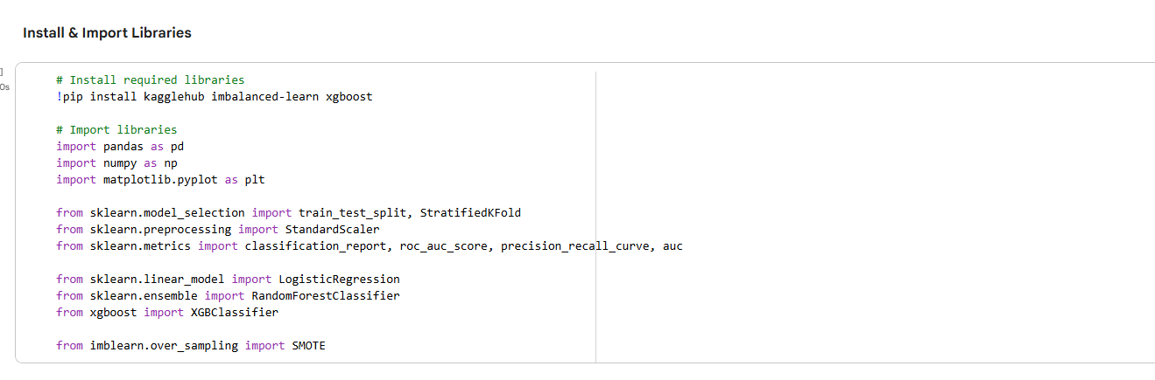
Figure 3.1: Importing Libraries
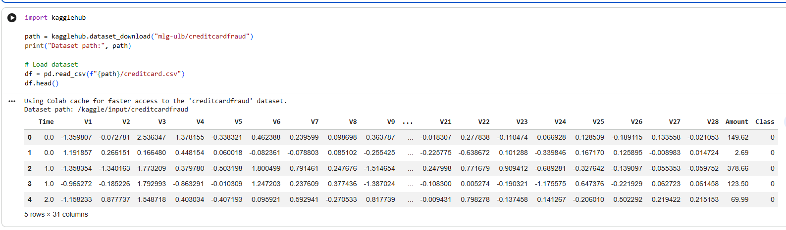
Figure 3.2: Downloading Dataset
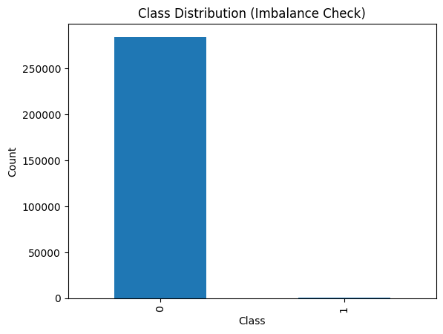
Figure 3.3: Class Distribution
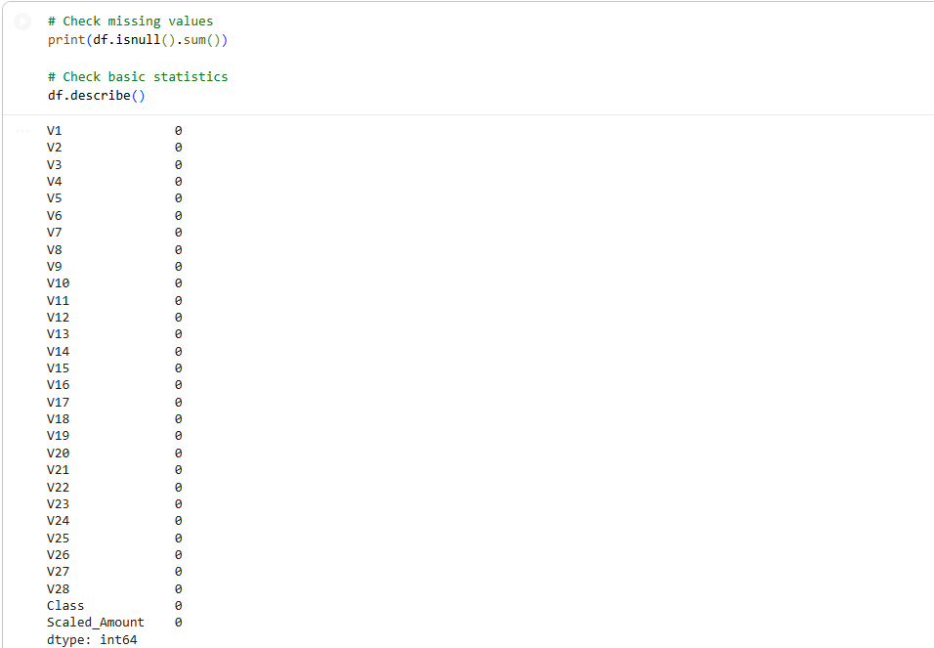
Figure 3.4: Checking For Missing Values

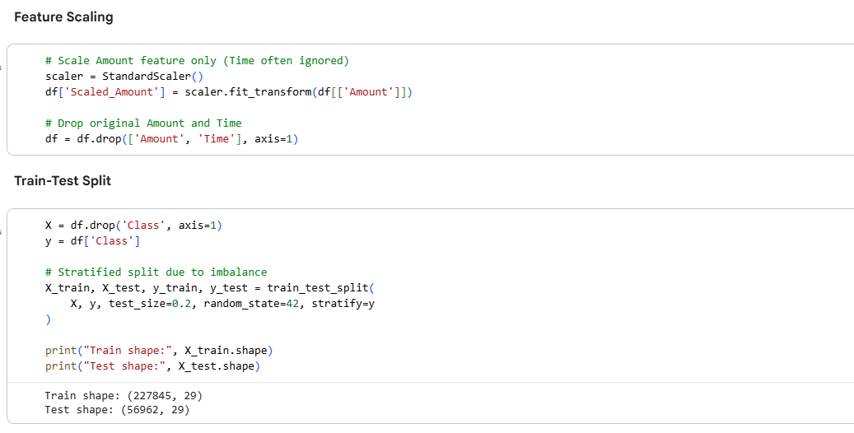
Figure 3.5: Feature Scaling and Train-Test Split
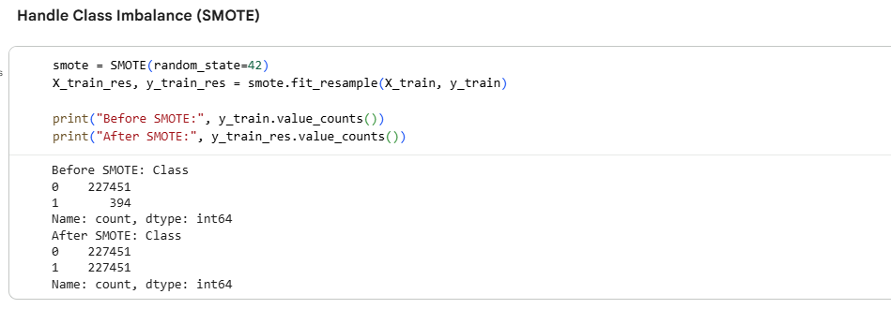
Figure 3.6: Handling Class Imbalance
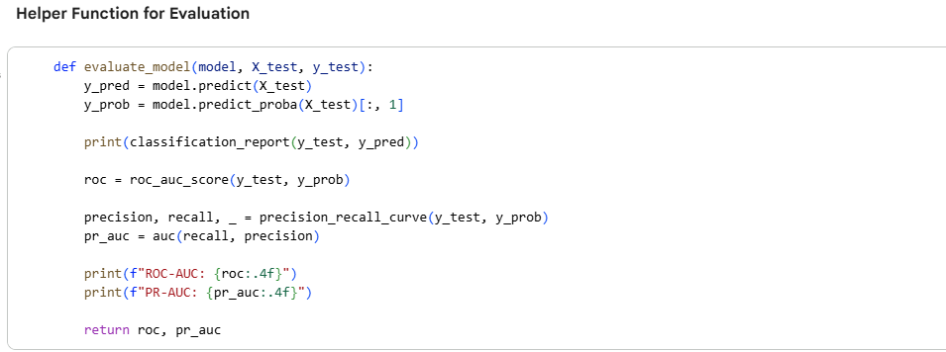
Figure 3.7: Evaluation Function
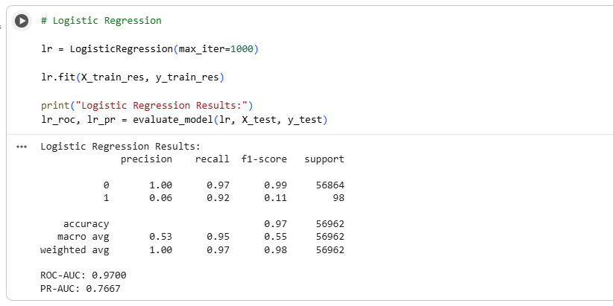
Figure 3.8: Logistic Regression Model
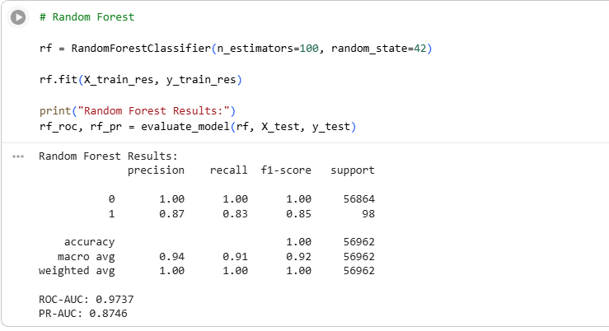
Figure 3.9: Random Forest Model
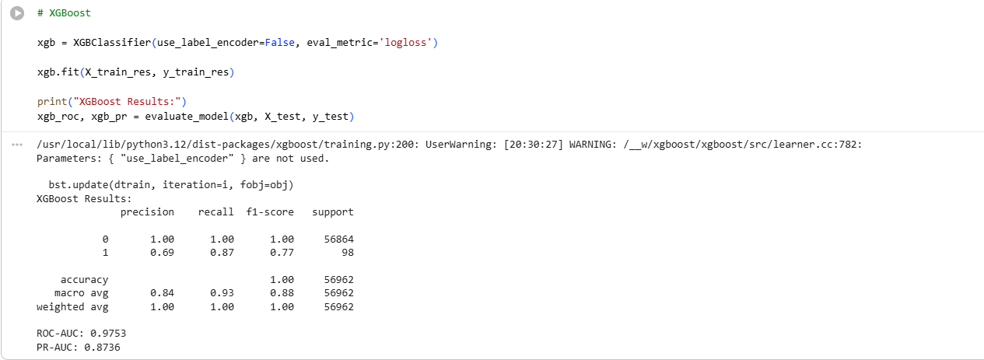
Figure 3.10: XGBoost Model
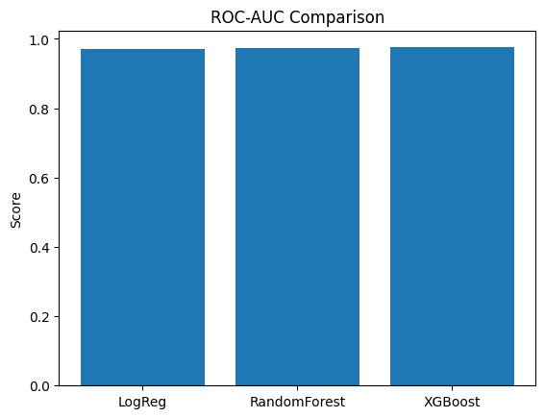
Figure 3.11: Model Comparison
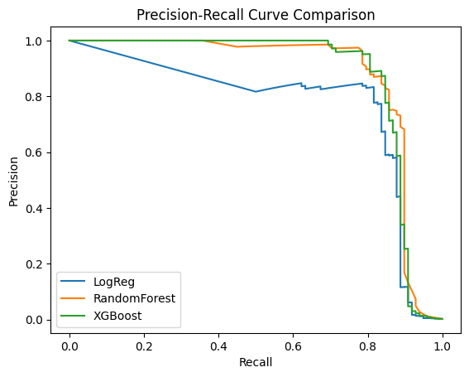

Figure 3.12: Precision-Recall Curve
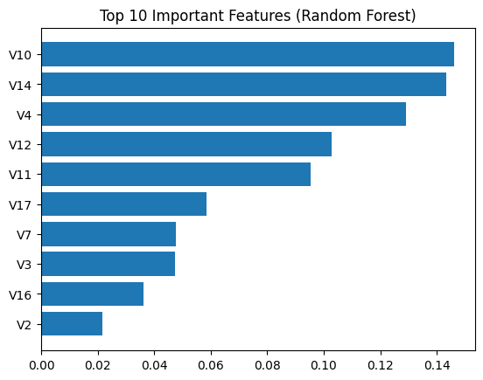
Figure 3.13: Important Features

References
- Chatterjee, P., Das, D. and Rawat, D.B., 2024. Digital twin for credit card fraud detection: Opportunities, challenges, and fraud detection advancements. Future Generation Computer Systems, 158, pp.410-426.
- Dastidar, K.G., Caelen, O. and Granitzer, M., 2024. Machine learning methods for credit card fraud detection: A survey. IEEE Access, 12, pp.158939-158965.
- Sailusha, R., Gnaneswar, V., Ramesh, R. and Rao, G.R., 2020, May. Credit card fraud detection using machine learning. In 2020 4th international conference on intelligent computing and control systems (ICICCS) (pp. 1264-1270). IEEE.
- Tanouz, D., Subramanian, R.R., Eswar, D., Reddy, G.P., Kumar, A.R. and Praneeth, C.V., 2021, May. Credit card fraud detection using machine learning. In 2021 5th international conference on intelligent computing and control systems (ICICCS) (pp. 967-972). IEEE.
- Ozioko, A.C., 2024. The use of artificial intelligence in detecting financial fraud: Legal and ethical considerations. Multi-Disciplinary Research and Development Journals Int'l, 5(1), pp.66-85.
- Patel, K., 2023. Credit card analytics: a review of fraud detection and risk assessment techniques. Available at SSRN 5280485.
- Rastogi, V., 2024. Exploring the Role of Artificial Intelligence in Enhancing Detection and Prevention of Banking Frauds: Legal and Ethical Implications. Issue 3 Int'l JL Mgmt. & Human., 7, p.4080.
- Găbudeanu, L., Brici, I., Mare, C., Mihai, I.C. and Șcheau, M.C., 2021. Privacy intrusiveness in financial-banking fraud detection. Risks, 9(6), p.104.
- Patil, D., 2024. Artificial intelligence in financial risk assessment and fraud detection: Opportunities and ethical concerns. Available at SSRN 5057434.
- Cherif, A., Badhib, A., Ammar, H., Alshehri, S., Kalkatawi, M. and Imine, A., 2023. Credit card fraud detection in the era of disruptive technologies: A systematic review. Journal of King Saud University-Computer and Information Sciences, 35(1), pp.145-174.
- Reshma, R., Santhosh, R. and Mekala, N., 2023, March. An analytical approach to fraudulent credit card transaction detection using various machine learning algorithms. In 2023 Second International Conference on Electronics and Renewable Systems (ICEARS) (pp. 1400-1404). IEEE.
- Hayat, K. and Magnier, B., 2025. Data Leakage and Deceptive Performance: A Critical Examination of Credit Card Fraud Detection Methodologies. Mathematics, 13(16), p.2563.
- Alarfaj, F.K., Malik, I., Khan, H.U., Almusallam, N., Ramzan, M. and Ahmed, M., 2022. Credit card fraud detection using state-of-the-art machine learning and deep learning algorithms. Ieee Access, 10, pp.39700-39715.
- Tiwari, P., Mehta, S., Sakhuja, N., Kumar, J. and Singh, A.K., 2021. Credit card fraud detection using machine learning: a study. arXiv preprint arXiv:2108.10005.
- Madhurya, M.J., Gururaj, H.L., Soundarya, B.C., Vidyashree, K.P. and Rajendra, A.B., 2022. Exploratory analysis of credit card fraud detection using machine learning techniques. Global Transitions Proceedings, 3(1), pp.31-37.
- Bin Sulaiman, R., Schetinin, V. and Sant, P., 2022. Review of machine learning approach on credit card fraud detection. Human-Centric Intelligent Systems, 2(1), pp.55-68.
- Boutaher, N., Elomri, A., Abghour, N., Moussaid, K. and Rida, M., 2020, November. A review of credit card fraud detection using machine learning techniques. In 2020 5th International Conference on cloud computing and artificial intelligence: technologies and applications (CloudTech) (pp. 1-5). IEEE.
- Roseline, J.F., Naidu, G.B.S.R., Pandi, V.S., alias Rajasree, S.A. and Mageswari, N., 2022. Autonomous credit card fraud detection using machine learning approach☆. Computers and Electrical Engineering, 102, p.108132.
- Khalid, A.R., Owoh, N., Uthmani, O., Ashawa, M., Osamor, J. and Adejoh, J., 2024. Enhancing credit card fraud detection: an ensemble machine learning approach. Big Data and Cognitive Computing, 8(1), p.6.
- Sizan, M.M.H., Chouksey, A., Tannier, N.R., Al, M.A., Jobaer, J.A., Roy, A., Ridoy, M.H., Sartaz, M.S. and Aminul, D., 2025. Advanced machine learning approaches for credit card fraud detection in the usa: A comprehensive analysis. Journal of Ecohumanism, 4(2), pp.883-905.
- Farabi, S.F., Prabha, M., Alam, M., Hossan, M.Z., Arif, M., Islam, M.R., Uddin, A., Bhuiyan, M. and Biswas, M.Z.A., 2024. Enhancing credit card fraud detection: A comprehensive study of machine learning algorithms and performance evaluation. Journal of Business and Management Studies, 6(3), pp.252-259.

